OFFICIAL COORDINATION REQUEST FOR
NON-ROUTINE OPERATIONS AND MAINTENANCE

COORDINATION TITLE- 14TDA07 additional flow survey work
COORDINATION DATE- 25 June 2014
PROJECT- The Dalles Dam
RESPONSE DATE- 10 July 2014 (FPOM)

Description of the problem- Per MOC 14TDA05, a survey has been coordinated for near the east fishway exit. TDA would like the survey crew to do some additional bathymetry work in front of units 19-22. This additional survey would help determine the amount of gravel loading in front of these units. It is believed the gravel has caused the problems with getting bulkheads to seal. The survey will occur both upstream and downstream of these units. Tailrace work would occur on 4 August and forebay on 5 August.

Type of outage required
Tailrace survey – To reduce the interference from the east ladder flow, the fish units would need to be OOS. Fish units F1 and F2 are already scheduled out for the ROV midseason grating inspection. Units 18-22 scheduled OOS for ½ day. U18 will be OOS to provide the safety buffer for the survey of units 19-22.

Forebay survey – ITS gates at U18 closed ~4 hours.

Impact on facility operation – On 4 August units 18-22 would be unavailable for half a day. The fish units would be OOS as well, but that is already coordinated as part of the mid-season ROV inspection.

On 5 August U18 sluice gate would be closed for about 4 hours. U18 sluice gates will be closed only when boat is in vicinity. Sluice gates on units 1 and 8 will remain open.

Dates of impacts/repairs – 4-5 August

Length of time for repairs – about four hours on each day.

Expected impacts on fish passage
Downstream migrants- Minimal impact in August, due to low subyearling passage. Five out of six sluice gates will remain open and in FPP criteria.

Upstream migrants- This work will occur within the 100’ buffer of the east fishladder exit required by the FPP. Below is a graph showing the 10 year average for adult passage at TDA. The bulk of the fish run may be avoided if the June surveys are scheduled for early in the month and November is chosen for the later survey.

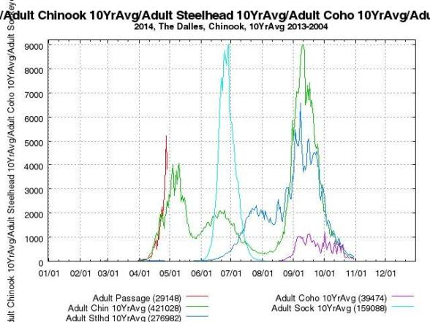

Bull Trout- Unknown. Occurrence in Action Area is highly unlikely. Of the five distinct population segments (DPS) of bull trout listed as threatened by the USFWS, the Columbia River DPS is the only one that is likely to occur in the vicinity of the proposed project. Historically, bull trout of the Columbia River DPS likely ranged through much of the Columbia River Basin with spawning and rearing occurring in the coldest creeks, often at higher elevations. Presently, bull trout of the Columbia River DPS are distributed in a more fragmented pattern throughout the Columbia River Basin with fewer adult migratory fish and fewer, more compressed spawning reaches than historically occurred.

WDFW and Corps personnel provided a list of anecdotal sightings/captures of bull trout in the mainstem Columbia River. From 2000 through 2012 there were eleven bull trout reported. Three were downstream of Bonneville Dam, with two at the mouth of Hamilton Creek (RM 143) and one in 2005 at the Bonneville Dam Smolt Monitoring Facility (RM 144). Upstream of the dam, one bull trout was found at Cascade Locks (RM 149), two at Drano Lake (RM 162), two at the mouth of the Klickitat River (RM 180.5), one in 2002 at the John Day Dam Smolt Monitoring Facility (RM 215), and one sighting at Dog Creek Falls by a reputable WDFW creel sampler who observed 18- to 24-inch cuts or dollies working old redds below the splash pool over the course of two weeks. Fish passage data from the Bonneville Dam fish ladders (Corps, unpublished) show only three sightings of bull trout moving through the fish ladders for 2000 through 2011 during the fish counting season (April 1 through October 31). These sightings occurred between May 30, 2009 and June 2, 2009 and were reported as ‘12-inch bull trout moving upstream’ through the count window on each occasion.

Lamprey- No expected impacts. This work will be completed outside the normal lamprey passage window.

Comments from agencies
NOAA Fisheries - -----Original Message-----
From: Gary Fredricks - NOAA Federal [mailto:gary.fredricks@noaa.gov]
Sent: Monday, June 30, 2014 7:42 AM
To: Mackey, Tammy M NWP
Cc: Lorz, Tom; Cordie, Robert P NWP
Subject: [EXTERNAL] Re: FPOM: Official Coordination - MOC 14TDA07 additional flow survey work

Tammy, I'm good with the additional survey work, however, if either unit 18 or sluicegate 18-2 is to be off or closed for more than 6 hrs (I'm not sure what is meant by a "1/2 day unit outage"), they will need to move down the powerhouse and open another gate as per the FPP guidance (TDA-12, Section 2.4.1.2.e.). Thanks, Gary

TDA Fisheries - -----Original Message-----
From: Cordie, Robert P NWP
Sent: Monday, June 30, 2014 1:59 PM
To: Gary Fredricks - NOAA Federal; Mackey, Tammy M NWP
Cc: Lorz, Tom; Keller, Paul S NWP
Subject: RE: [EXTERNAL] Re: FPOM: Official Coordination - MOC 14TDA07 additional flow survey work (UNCLASSIFIED)

Classification: UNCLASSIFIED
Caveats: NONE

They were estimating 4 hours last I heard. We'll double check and plan to move gates if longer.

Final results

Please email or call with questions or concerns.
Thank you,
Tammy

Tammy Mackey
NWP Operations Division Fishery Section
Columbia River Coordination Biologist
503-961-5733
Tammy.m.mackey@usace.army.mil

